Challenge- Trebuchet

Subject:  Related Subjects: | Grade Level(s):  Length of Lesson: | Type: Inquiry / Design / Project  Keywords:

Lesson Overview
Use this section to describe at a high level what the lesson is. Should be no more than 3-4 lines.

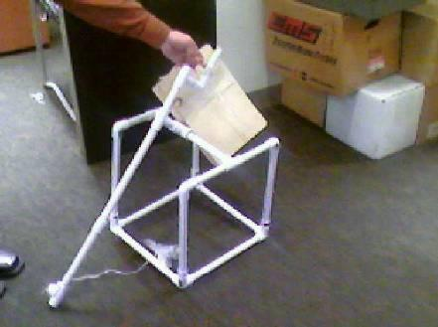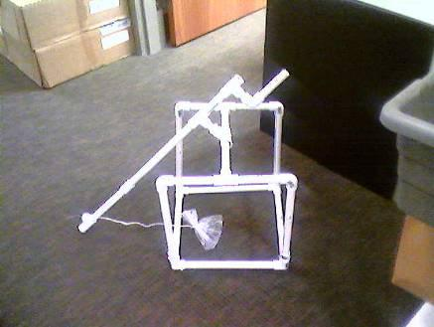

Lesson Focus
- Create different configurations and test them varying one component under multiple conditions while keeping others constant.

Lesson Objective(s) | Middle School – Using any materials, create a trebuchet that will perform the following tasks:  (1) Distance - farthest distance thrown of a single projectile  (2) Accuracy – nearest distance projectile impacts to two ground level targets  - High School – Using any materials, create a trebuchet that will perform the following tasks:  (1) Distance - farthest distance thrown of a single projectile  (2) Accuracy – nearest distance projectile impacts to two ground level targets  (3) Strength – greatest mass of projectiles delivered to a vertical target

Lesson Timing

5 minutes | Introduce the Lesson
30 minutes | ...

Materials | - Material (plywood, balsawood, foam board, dowels)  - Rotating arm type (wood, metal, plastic)  - Rotating arm length (short, medium, long)  - Sling string type (fishing line, string, yarn)  - Sling type (staff sling attached to the throwing arm of the trebuchet OR an attached sling (string) connected directly to the projectile)  - Projectile placement (underneath, extended back)
Instructor Prep | - Step 1
Related Resources | - List related lessons/ppts etc available from USC or outside, trusted orgs

Lesson Plan

Introduction
There are obviously many more components that can be varied and many more variations on the components listed. The goal of this activity is to get your students to use a scientific process when deciding on the best design for their car. During this process you may have them relate physics and engineering concepts to the variations that they create.

Testing:
In today’s workshop, you will choose one of the variable components to change while keeping the others constant and record your results.

 | Trial 1 | Trial 2 | Trial 3
Projectile String Length
Rotating Arm length
Projectile placement
Distance thrown

Fixed constants (supplied for workshop):
- Material – K’nex
- Rotating arm type – K’nex
- Sling type – Thread attached to projectile
- Max height rotating arm pivot – 6”
- Max height counter weight – 10”

Variable components:
- Size and shape of trebuchet (maintaining rotating arm and counterweight restrictions)
- Rotating arm length
- Projectile placement
- Projectile sling string length

Constants:
    - Rotating arm length – 12”_______________

    - Projectile placement – underneath ______

    - Size of trebuchet ________________

Variable:
    - Projectile sling string length_________________

Configuration:

Upside down “T” Formation with rotating bar._

Procedure

Create different configurations and test them varying one component under multiple conditions while keeping others constant.

In today’s experiment, students will work in groups of 4 – 6. They will choose values for the variable components launch the projectile and record their results. If time permits, students can alter one of the variables and re-launch. Have students discuss results

Fixed constants (supplied for workshop):
- Material – PVC
- Rotating arm type – PVC
- Sling type – Thread attached to projectile (Ziploc bag of water)
- Height rotating arm pivot ≈ 30cm
- Size and shape of trebuchet

Variable components:
- Rotating arm length
- Projectile placement
- Projectile sling string length

Wrap-up

Testing:

Constants:
    - _________________________________

    - _________________________________

    - _________________________________

Variable:
    - _________________________________

Configuration:
_____________________________________________________________

_____________________________________________________________

_____________________________________________________________

_____________________________________________________________

Enter results in table

 | Trial 1 | Trial 2 | Trial 3
Projectile String Length
Rotating Arm length
Projectile placement
Distance thrown

Lesson Background for Teachers

Suggested Real-World STEM Connections
- List possible related Role Models in STEM (with details and links to more reading). Give suggestions for examples of scientists/engineers who are from underrepresented groups in STEM in related careers.
- List related real-world engineering problems and examples

Lesson Variations and Options
- Material (plywood, balsawood, foam board, dowels, pvc)
- Rotating arm type (wood, metal, plastic)
- Rotating arm length (short, medium, long)
- Sling string type (fishing line, string, yarn)
- Sling type (staff sling attached to the throwing arm of the trebuchet OR an attached sling (string) connected directly to the projectile)
- Projectile placement (underneath, extended back)

There are obviously many more components that can be varied and many more variations on the components listed. The goal of this activity is to get your students to use a scientific process when deciding on the best design for their trebuchet. During this process you may have them relate physics and engineering concepts to the variations that they create.

Explanation
Describe the background concepts and explanations behind the lesson. This can be more in depth than a teacher/instructor would actually share with students.

Key Concepts and Vocabulary
- Word 1: Grade Appropriate Definition
- Word 2: Grade Appropriate Definition

Safety Notes
- Safety instruction

